

**Website User Manual**

December 2014

Introduction to the new **Skalez Games** Website

The Skalez Games site was developed as a team project for the Web Project (CPD-4303) class. Members of the team are Scott Melanson, Lewis Menelaws, and Ashika Shallow. The site is about a retail gaming company where customers can view our products.

Building on the skills learned during previous and current semesters, our site provides functionality and features such as:

* Accessing a database using PHP and MySQL
* User access via a login page
* A register page for new users
* A version compatible with mobile devices

This manual explains the ways in which to use the site.

Navigating



The navigation bar offers quick access to the different sections of the site. The logo is a link to the home page, the ‘Games’ tag is a link to our products page. To find out information about our company and its founders, click the ‘About’ tag.

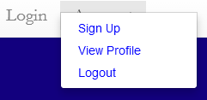The ‘Account’ tag is a drop-down list containing links to a sign up page, a user’s profile page, and a log out action link.

The social media icons provides access to the company’s Facebook and Twitter pages, as well as access to team member Lewis’s GitHub page, and the Lambton CPRO Reddit page.

Logging In

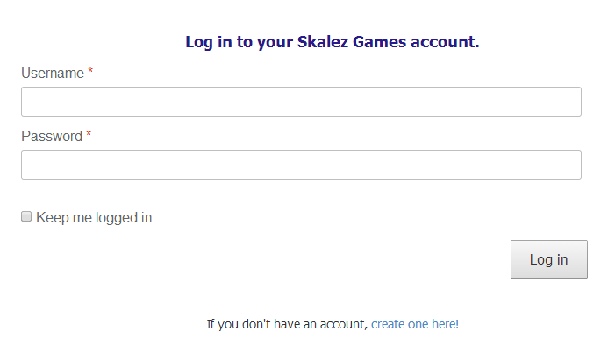

A client can log in to view and make changes to their profile. If a user does not have account, he can click the link at the bottom of the login page or the ‘Sign Up’ link in the Account drop-down list on the navigation bar.

Registering

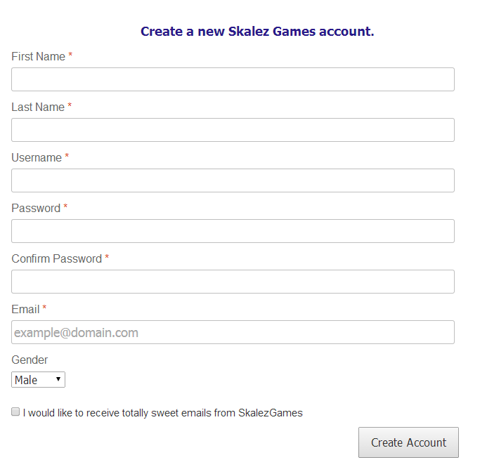

A new user can register with our company using social media or providing us with the credentials. All the fields are required, a valid, unique email must be entered. If registration was successful, the user will be directed to his account page.

User Profile

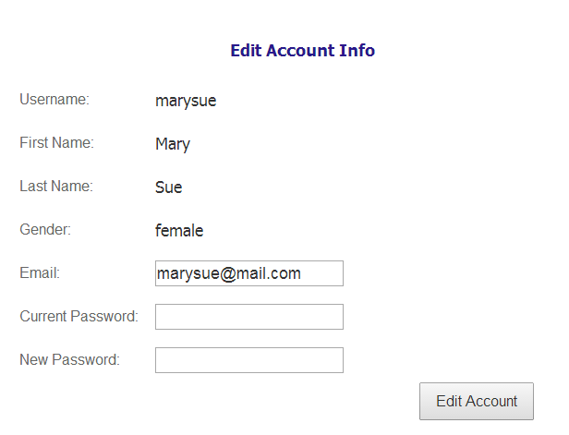

When logged in, the user will be directed to his profile page where he’ll be able to see his account information and edit that information – email and password – if he wishes.